OTA Design:
We will start the design by trying to make it single stage and single pole. We will using the folded cascode:
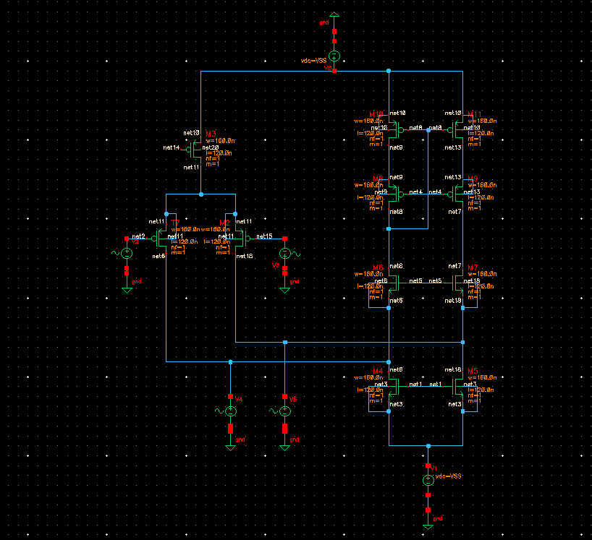 If the system is single pole, this means that the GBW reads $130⋅{10}^{6}$, using the equation for GBW we find the $g_{m1}$:
$$GBW=\frac{g_{m1}}{2πC_{L}}→g_{m1}=GBW*2πC_{L}=8.16 mS$$
This is a relatively high $g_{m1}$. The main idea will be to keep the transistors small so that no more poles form on the system.
The $gm$ equation reads:
$$g_{m}=\frac{2I_{DS}}{V_{GS}-V_{th}}$$
To get a high gm we can both increase the Ids or decrease the overdrive voltage. Increasing the Ids without touching the overdrive means to increase the transistor size. Decreasing overdrive without touching the current means increasing transistor size as well to compensate.
Here we see the first problem which is that the source of the input transistors are the drain of the active load M3.
We will start with a (comfortable) target source of 0.5V on the input sources. The drain of these transistors should be smaller than $V_{tp}$ because the gate is 0VDC and the saturation rule reads:
$$V_{DG}<-V_{tp}$$
So we will start with 0.3V.
We start by setting the length of the input transistors to $L_{in}=200nm$ and iterate through their width. Assuming a $V_{ov}=200mV$ we should get $I_{DS}≅g_{m1}*\frac{V_{ov}}{2}=800μA$.
We found a close result for $W_{L,in}=130 μm$:
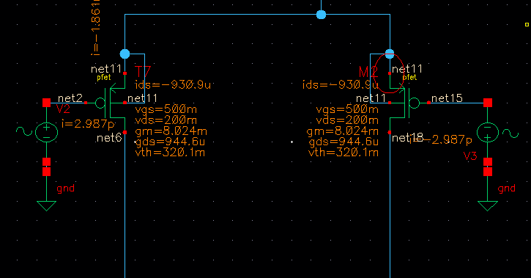
We notice that both transistors need to be fed by M3 so we’ll choose M3 width such that it’s current is 1.86mA ($L_{3}=200nm)$:
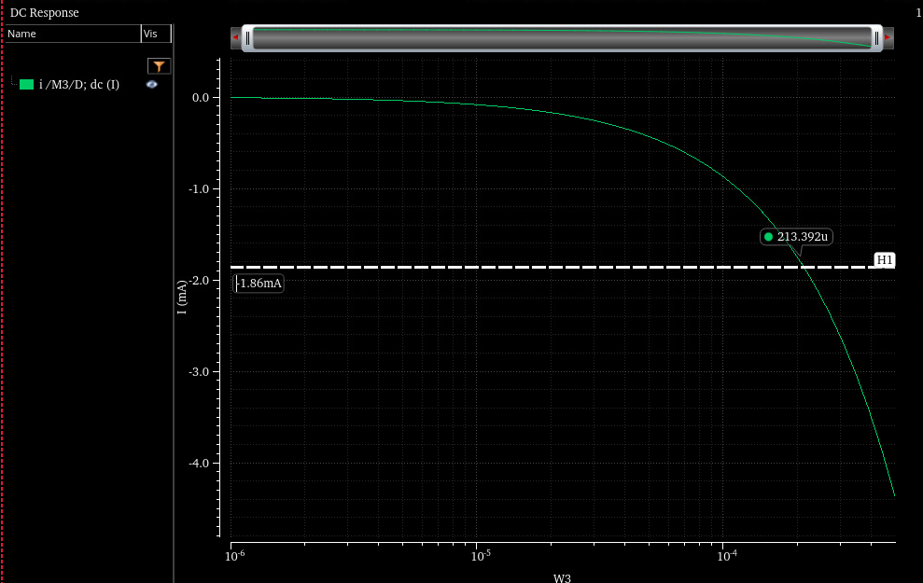
So we choose $W3=213.4 μm$.
Next we need to set the output resistance.
The output resistance at each node is given by:
$$R_{out}=\left[g_{m7}r_{o7}⋅\left(r_{o5}∥r_{o2}\right)\right]∥\left[g_{m9}r_{o9}r_{11}\right]$$
We need to achieve 1000 gain. Therefore, the Rout is given by:
$$R_{out}=124.6 kΩ$$
We will assume that $r_{o2}≈r_{o5}$ and therefore the equation reads:
$$R_{out}=\left[g_{m7}r_{o7}⋅\left(\frac{r_{o2}}{2}\right)\right]∥\left[g_{m9}r_{o9}r_{11}\right]$$
Moreover, we will assume that: $g_{m7}r_{o7}⋅\left(\frac{r_{o2}}{2}\right)≈g_{m9}r_{o9}r_{11}$ so that:
$$R_{out}=\frac{g_{m7}r_{o7}r_{o2}}{4}$$
From DC point analysis we get:
$$r_{o2}≈1kΩ$$
This will require that $g_{m7}r_{o7}≅500$ which is unreasonable for a single stage (usually 10 or 20).
Because this seems unreasonable to achieve we will aim for $r_{o2}=50kΩ$ wich means increasing the $L$ by a factor of 50 and using the multiplier option on the transistor to get the desired width without increasing the parasitic impedance too much.

Start with L = 5mu and sweep on W = 50u and multiplier value Fin.
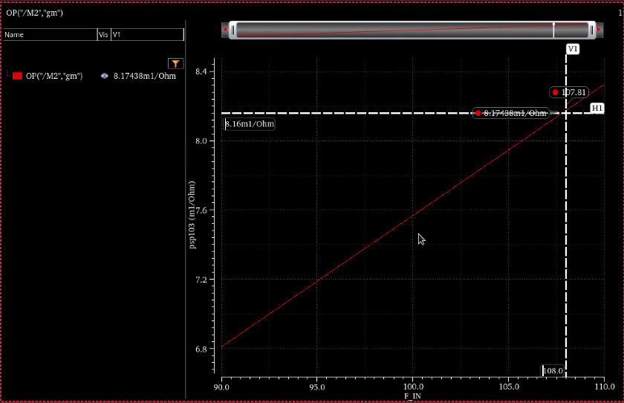
F_in = 108
